Period End Closing – CRIM 0334

|  |  |  |  |  |
| --- | --- | --- | --- | --- |
| **Ver** | **Date** | **Author** | **Comments** | **Reviewed by** |
| 1 | 27/11/2020 | Tom Bell | CRIM 0334 | TBC |
|  |  |  |  |  |

Requirements 2

Prerequisites 2

Solution Overview 2

Solution Details 2

Security 3

Companies 3

Data Migration 3

Test Steps 3

Technical Implementation 3

Requirements

At month end, the Non-Finance User Group must close overnight.

Prerequisites

<Describe any pre-requisites that this development may rely upon, data configuration or other developments>

Solution Overview

At month end, the Non-Finance User Group must close overnight to prevent Non-Finance users from carry on working in the previous month the next morning.

Solution Details

At month end, the Non-Finance User Group must close overnight to prevent these Users from carrying on working in the previous month.

The automatic closure at month end for Non-Finance User groups can be linked to the “Account Periods” table. Once the “Valid Until Date” has passed, the system should close the Non-Finance Group. However, Financial Accounting (User Groups AC, AP and AR) needs the ability to manually reopen and close periods.

The below screenshot shows the Accounting Periods table. Once the “Valid Until Date” has passed the system needs to close the period for the Non-Finance User Group.

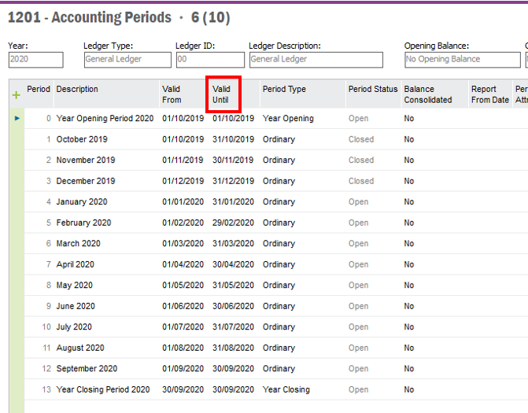

The below screenshot shows the User Groups currently set up. The “NF – Non-Finance User Group” must close at month end.

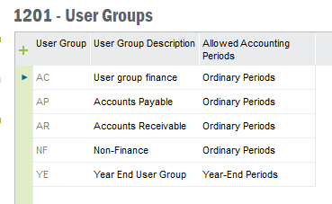

**Technical.**

Field Definitions.

<New Field/CLU Definition>

|  |  |  |  |  |  |  |
| --- | --- | --- | --- | --- | --- | --- |
| New DB Object Name | DB Object Item/Field Names | Item Description | Item Data Type | Item Syntax | Calculation Spec, if Derived | LOVs/Enums/Is Mandatory? |
|  |  |  |  |  |  |  |
|  |  |  |  |  |  |  |
|  |  |  |  |  |  |  |
|  |  |  |  |  |  |  |
|  |  |  |  |  |  |  |
|  |  |  |  |  |  |  |
|  |  |  |  |  |  |  |
|  |  |  |  |  |  |  |
|  |  |  |  |  |  |  |
|  |  |  |  |  |  |  |
|  |  |  |  |  |  |  |
|  |  |  |  |  |  |  |

Security

|  |  |
| --- | --- |
| **User Group** | **Privileges** |
| Non-Finance | Only work in current period. User group is closed at month end automatically. |
| Financial Accounting | Reopen and close periods manually. |

Companies

Applies to the following companies. All.

|  |  |
| --- | --- |
| **Company** | **Required (Y/N)** |
| 1201 | Y |
| TBC |  |
|  |  |

Data Migration

<Describe any data migration impacts this development may have – i.e additional data to be migrated>

Test Steps

<Steps that needs to be taken to test this change. Please provide expected results> Updated post solution.

|  |  |  |
| --- | --- | --- |
| **No** | **Script\Test Steps** | **Expected Result** |
| 1 | Financial Accounts User Group reopen and close accounting periods manually. | Can reopen and close accounting periods manually. |
| 2 | Non-Finance User Groups try to work in the previous month after month end. | Cannot work in the previous month after the morning after month end. |

Technical Implementation

1. New method implemented - ‘Close_Non_Finance_User_Group’ in C_EA_Customization_Util_API Package.
2. New ins file - CloseNonFinanceUserGroup.ins in order to register the batch schedule method.



1. Go to ‘New Database Task Schedule’ window. – Create new record.

Task Name – Query by giving ‘C_EA_Customization_Util_API.Close_Non_Finance_User_Group’ as the method name.

